**Odd-Even Sort:**

**An odd-even sort is also called odd-even Transition sort or Brick sort or Parity sort.**

**Developed originally to use on parallel processors with local interconnections.**

**Worst Time complexity: O(n^2)**

**Best Time complexity: O(n)**

**Worst space complexity: O(1)b**



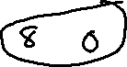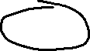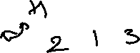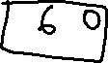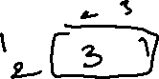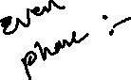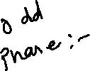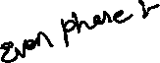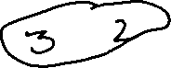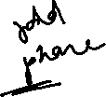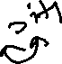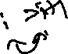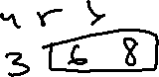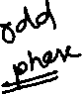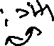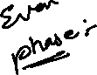

**As there are 6 Elements we need 6 iterations to get sorted on 7th iteration or N+1 iteration the array get sorted**

